20250715 LGOIMA following CE response

From: Contact Legal <contact.legal@tcdc.govt.nz>
Sent: Wednesday, 13 August 2025 2:50 pm
To: ian@moisturedetection.co.nz
Subject: Response - Information request

Dear Ian

I refer to your request for information dated 15 July 2025. Please see below responses and documentation within this link:  LGOIMA RESPONSE 15072025

- On page 5 states ‘The following documents were all released on 22/04/2025
Can you please indicate how these were ‘released’ and how I could get a copy. Could you please send me copies.
- Please refer to Anouska’s response of 16/07/2025

- On page 6 in respect to the Gamble report (or letter) the letter states ‘At that time, it was refused on it being a draft only’. Whilst I have the right to dispute releasing documents as draft it would appear that this document is no longer a draft so can I please have a copy.
Please find enclosed in the link:
- The ‘Gamble report’ refers to the Comprehensive Stormwater Discharge Consent – Stormwater Management Plan September 2020, drafted by K. Gamble which was still in draft format.
- The latest iteration of the CSDC Stormwater Management Plan 2025 has been submitted to review to WRC 31/07/2025 (enclosed).

- On page 7 can I please have a copy of the latest annual report 2023/24 for CSDC 105667
- Please refer Anouska Greene’s response of 16/07/2025

- On page 7 references are made to comparisons between the HAL and Opus calculations. It includes a statement that much of Whangamata’s Pipe network is likely undersized. Have these comparisons been put into a spread sheet to identify or rank how undersized each pipe network is, how many properties become affected and what actions/costs are required to meet the 10%AEP event?
- No - it is important to understand this “general statement” is based on the rainfall intensity (which has been significantly increased as a result of climate change) used in the calculations.
- As a result no comparisons have been undertaken

- To question 4 above, if not, is it planned to continue this comparison for future programming of CAPEX options?
- Future programming of stormwater pipeline renewals is driven by a combination of factors -condition, performance, and risk;
- Physical condition of pipe – Identified by CCTV inspections - common defects like cracks, corrosion, deformation, joint failure, total collapse etc.
- Performance and level of service failure – Identified by RFS (Customer complaints and call outs), flooding reports, hydraulic modelling.
- Risk – Prioritizing renewal based on risk and criticality assessments
- Other drivers can be regulatory requirements, high operational costs and coordination with other projects and departments across the council.
- Specifically pipe capacity is assessed when pipelines are renewed to include the following;
- Changes in the catchment- New developments, more roofs, roads, parking lots- increased impervious surface
- Climate change – Future climate change projections to ensure that the system is resilient.
- Updated Level of service targets – upgrade /renewals due to a change in legislation. Currently the TCDC Level of Service (LOS) for stormwater pipe reticulation is 20% AEP rainfall event. However, Council is proposing to adopt the National Engineering Design Standards when they are released. The LOS for stormwater reticulation is 10% AEP in NEDS and to anticipate this adopted TCDC has been utilising this LOS for sizing stormwater pipeline reticulation.
- TCDC is not developing a spreadsheet of stormwater pipe capacity, areas which are affected by flooding and actions required to meet a 10% AEP rainfall event for Whangamata.

- On page 7 the table refers to HiRDS version 2 at 68.1mm/hr. Where does council obtain the actual Whangamata rainfall figures?
- Treated wastewater irrigation ponds, Watt Road, Whangamata.

- On page 8 under High Flood Hazard Area = 58 properties the qualification is a reduction of 19 properties removed from the Whangamata area being addressed leaving 39 properties only in High Flood Hazard Area. Please provide a map showing these properties and what council is proposing to reduce the flood hazard below high?
  - Please find enclosed in the link maps with the HIGH risk flood areas highlighted in yellow surrounded by blue line. The maps also include the flood extent line and flood model depth. There is also commentary on the maps, if the high-risk flooding is within an existing stormwater drain, it represents a basement or the property has been modified since 2013 (e.g. there may not be a flood risk could have changed).
- The flooding in Whangamata was assessed as part of the Whangamata Stormwater Improvement Project Master Plan, which included all the areas identified as high-risk flooding. Specifically refer to the following options:
- Option 1.01
- Option 1.02
- Option 3.04
- Option 4.03
- Option 4.04
- Option 4.07
- Option 4.10
- Option 5.01
- Option 5.04
- Option 5.06
- Option 6.04
- Option 7.01
- Option 7.03
- Option 8.01
- Option 8.02

- Pages 8 - 10 relate to flood hazard management. I have a number of questions regarding councils obligations but I think this would be better directed directly to the Water Services Manage as opinion and policy do not form part of LGOIMA responses.
- This is a Statement. No response required under LGOIMA.

- Page 10 includes comparisons between a number of reports. In previous LGOIMA requests council could not locate these reports. Accordingly they have been found could you please provide me with copies:

  - The Woodward Clyde Report
  - The Airey Consultants report
  - The flood modelling (maps I presume) of the Woodward Clyde and Opus 2005 reports.

- An extensive search has been undertaken for the Woodward Clyde and Airey Reports and they cannot be located in our data system or hardcopy.
- This including contacting the relevant consultants checking their files.
- Please note Woodward Clyde does not exist anymore, it was sold to URS then AECOM, and we contacted AECOM and WPS (who acquired Opus) to check if they had copies.
- The statement provided in the previous LGOIMA response is taken from information provided in the 2005 Opus report.
- As detailed in the Complaint to Chief Executive Investigation 4 July 2025, the Woodward Clyde, Airey and Opus reports did NOT include stormwater flood modelling. Therefore, no stormwater flood modelling maps are available.
- Given the above comments, we are therefore refusing this part of your request, relying on Section 17(e) of the LGOIMA, that the documents, despite reasonable efforts to locate them, cannot be found.

- Page 12 ‘templates’ please forward copes of each of the templates.
- These are provided in the link

- Page 14 second the last paragraph – The Technical staff present information to the group. Please send a copy of the ‘present information to the Group’ for the 21 February 2025 workshop specifically relating to the Hetherington Pipe Upgrade project
- Refer to the powerpoint presentation Whangamata_Stakeholder Meeting 20250221.pdf. provided in the link
- Full versions of the Hetherington Road hydraulic grade lines are included in the Whangamata Stormwater Improvement Master Plan.

- Page 51 includes this title in the 3rd last paragraph Whangamata SW Capital Works Master Plan. Please send me a copy.
- Please note a typo on page 51 of the document. It states, “It has also been considered as part of the Whangamata SW Capital Works Master Plan.” It was referring to and should have stated “Whangamata Stormwater Improvement Project Master Plan”.
- The ‘Whangamata Stormwater Master Plan – Proposal, HAL – Morphum Environmental, Nov 2018’ was a proposal to Council to develop a “Master Plan”. This was never progressed beyond this proposal except to commission a draft ‘Strategic Context and Risks Draft Report, Morphum Dec 2019’. The Whangamata Stormwater Master Plan was never progressed. Both of these documents have been issued to Ian Holyoake.
- Refer to the link for the Whangamata Stormwater Improvement Master Plan. Note this plan is a dynamic document and consistently changes.

- On page 3 please provide a copy of the Stormwater Improvement Master Plan
- This is included within the link – please refer to Item 12

- On page 4 I refer you to The initial projects selected for 2024/25 were the upgrade of the Hetherington Road which I take from page 28 2nd last paragraph of the complaint response Legal TC 4 July 2025 as the origin of the ‘initial projects’ assessed under the Kepner Tregoe Matrix Assessment (the Matrix). Please provide a copy as provided by each of the respective participants in the workshops and the summary compiling all these into the statement The initial projects selected for 2024/25 were the upgrade of the Hetherington.
- Please refer to the Matrix Summary in Step 5 of the Whangamata Stormwater Improvement Project Master Plan (attached Item 12).
- In providing a summary rather than the individual Kepner Tregoe Matrix’s, Council has decided to withhold identifying information relying on section 7(2)(a), to protect the privacy of people. In making the decision to withhold the information under section 7 I do not consider there to be a countervailing interest warranting its release. You have the right to seek an investigation and review by the Ombudsman of this decision. Information about how to make a complaint is available at www.ombudsman.parliament.nz or freephone 0800 802 602.

Ngā mihi | Regards

Jen Amner
Legal Coordinator

Thames-Coromandel District Council
Private Bag 1001, 515 Mackay Street, Thames
p: 07 868 0200
e: contact.legal@tcdc.govt.nz
w: www.tcdc.govt.nz


The contents of this e-mail may be CONFIDENTIAL OR LEGALLY PRIVILEGED, and is intended only for the persons named above. If this e-mail is not addressed to you, you must not use, read, distribute or copy this document. If you have received this document by mistake, please call us and destroy the original. Thank you.

Please consider the planet before printing out this email. Thank you.

From: Contact Legal <contact.legal@tcdc.govt.nz>
Sent: Wednesday, 16 July 2025 11:55 AM
To: Ian Holyoake <ian@moisturedetection.co.nz>
Subject: Acknowledgement - Information request

Dear Ian,

Thank you for your email. I acknowledge receipt of the information requests. As always, we will respond to your request as soon as possible, and in any event no later than 12 August 2025. If we are unable to respond to your request by then, I will notify you of an extension of that time frame.

I have provided a response to some of your items below.

- Item 1
These documents were released to you via email from me on 22/04/2025 (attached). I have provided access to the folder again for your convenience.

Ian Holyoake

- Item 3
Our 2023/2024 annual report is available online Annual Report 2023-2024 | TCDC
- Item 12
The Whangamata SW Capital Works Master Plan, I believe, is contained within the folder above, document named ‘Whangamata Stormwater Master Plan – Proposal, HAL – Morphum Environmental, Nov 2018’. However, I will check this is the correct document with the Water Services team.

Regards,
Anouska Greene
Legal Technical Specialist (LGOIMA/Privacy)
Monday, Wednesday, Thursday and Friday
Thames-Coromandel District Council
p: 07 868 0200
e: anouska.greene@tcdc.govt.nz
w: www.tcdc.govt.nz
The content of this e-mail may be CONFIDENTIAL OR LEGALLY PRIVILEGED, and is intended only for the persons named above. If this e-mail is not addressed to you, you must not use, read, distribute or copy this document. If you have received this document by mistake, please call us and destroy the original

From: Ian Holyoake <ian@moisturedetection.co.nz>
Sent: Tuesday, 15 July 2025 3:45 PM
To: Contact Legal <contact.legal@tcdc.govt.nz>
Subject: Information request

Hi Anouska

I have attached 2 documents I will refer to.
One is the Chief Executives response to our complaint (Legal TC 4 July 2025) and the other a word download of TCDC website page on Whangamata stormwater (I have highlighted in yellow on this one).
The information I seek comes from these documents.

From the pdf Legal TC 4 July 2025 document

- On page 5 states ‘The following documents were all released on 22/04/2025

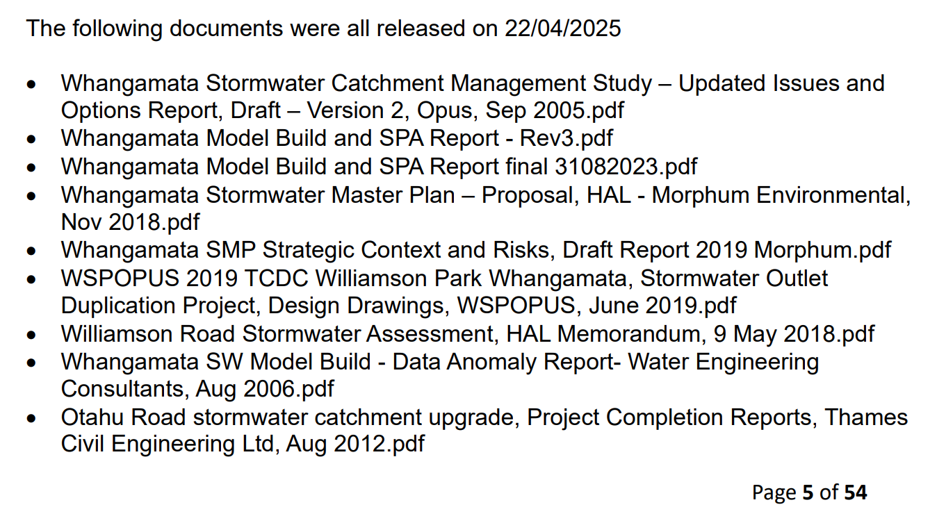

Can you please indicate how these were ‘released’ and how I could get a copy. Could you please send me copies.

- On page 6 in respect to the Gamble report (or letter) the letter states ‘At that time, it was refused on it being a draft only’. Whilst I have the right to dispute releasing documents as draft it would appear that this document is no longer a draft so can I please have a copy.

- On page 7 can I please have a copy of the latest annual report 2023/24 for CSDC 105667

- On page 7 references are made to comparisons between the HAL and Opus calculations. It includes a statement that much of Whangamata’s Pipe network is likely undersized. Have these comparisons been put into a spread sheet to identify or rank how undersized each pipe network is, how many properties become affected and what actions/costs are required to meet the 10%AEP event?

- To question 4 above, if not, is it planned to continue this comparison for future programming of CAPEX options?

- On page 7 the table refers to HiRDS version 2 at 68.1mm/hr. Where does council obtain the actual Whangamata rainfall figures?

- On page 8 under High Flood Hazard Area = 58 properties the qualification is a reduction of 19 properties removed from the Whangamata area being addressed leaving 39 properties only in High Flood Hazard Area. Please provide a map showing these properties and what council is proposing to reduce the flood hazard below high?

- Pages 8 - 10 relate to flood hazard management. I have a number of questions regarding councils obligations but I think this would be better directed directly to the Water Services Manage as opinion and policy do not form part of LGOIMA responses.

- Page 10 includes comparisons between a number of reports. In previous LGOIMA requests council could not locate these reports. Accordingly they have been found could you please provide me with copies:

  - The Woodward Clyde Report
  - The Airey Consultants report
  - The flood modelling (maps I presume) of the Woodward Clyde and Opus 2005 reports.

- Page 12 ‘templates’ please forward copes of each of the templates.

- Page 14 second the last paragraph – The Technical staff present information to the group. Please send a copy of the ‘present information to the Group’ for the 21 February 2025 workshop specifically relating to the Hetherington Pipe Upgrade project

- Page 51 includes this title in the 3rd last paragraph Whangamata SW Capital Works Master Plan. Please send me a copy.

From the 20250711 TCDC Website word doc.

- On page 3 please provide a copy of the Stormwater Improvement Master Plan

- On page 4 I refer you to The initial projects selected for 2024/25 were the upgrade of the Hetherington Road which I take from page 28 2nd last paragraph of the complaint response Legal TC 4 July 2025 as the origin of the ‘initial projects’ assessed under the Kepner Tregoe Matrix Assessment (the Matrix). Please provide a copy as provided by each of the respective participants in the workshops and the summary compiling all these into the statement The initial projects selected for 2024/25 were the upgrade of the Hetherington.

Thank you.

I will deal with other matters arising from the Media release and complaint response later.

Regards

Ian Holyoake
Managing Director
M 021 607 611
The Moisture Man. The proof is in the probes.


