20250213 Metis website stormwater Whangamata

<https://metisconsultants.co.nz/case-studies/whangamata-stormwater-master-plan/>

* [About Us](https://metisconsultants.co.nz/about-us/)
* [Three Waters](https://metisconsultants.co.nz/water/)
* [Asset & Carbon Management](https://metisconsultants.co.nz/asset-carbon-mgmt/)
* [Land Development](https://metisconsultants.co.nz/land-development/)
* [Join Us](https://metisconsultants.co.nz/careers/)
* [News](https://metisconsultants.co.nz/news/)

[Contact Us](https://metisconsultants.co.nz/contact-us/)

[](https://metisconsultants.co.uk/)[](https://metisconsultants.co.nz/)

[Home](https://metisconsultants.co.nz) › [Case Studies](https://metisconsultants.co.nz/case-studies/) › [Whangamata Stormwater Master Plan](https://metisconsultants.co.nz/case-studies/whangamata-stormwater-master-plan/)

**Whangamata Stormwater Master Plan**

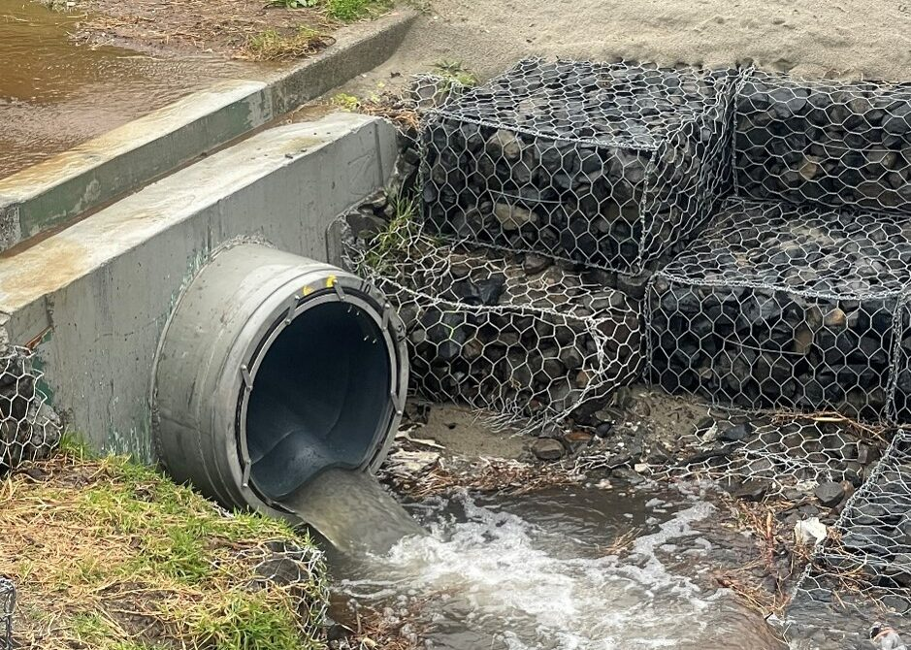

**Project overview**

Metis worked with Thames-Coromandel District Council to generate a multi-year programme of stormwater works in Whangamata.

**Our approach**

* Identify homes and critical infrastructure at greatest risk of stormwater flooding
* Generate mitigation options for each area at risk
* Engage with residents to prioritise mitigation options
* Generate an annualised implementation programme based on resident feedback and available funding

**Outcomes**

* Improved stormwater management: Proposed works will transport stormwater away from homes and businesses, reducing risk of flood damage
* ‘Bang for buck’: Targeted programme of stormwater works that benefits the most people relative to capital cost
* Climate change resilience: Pipe networks designed to better accommodate climate-change driven increases in rainfall as well as sea level rise

**PROJECT CONTACT**

Michael Arthur

Project Director

E: [michael@metisconsultants.co.nz](mailto:michael@metisconsultants.co.nz)

T: [022 071 4653](tel:0220714653)

**Related Projects**

[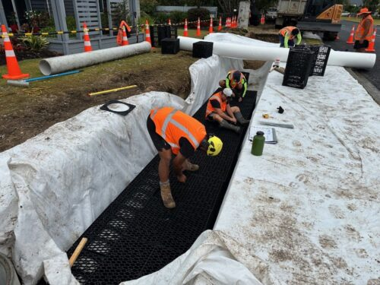](https://metisconsultants.co.nz/case-studies/cook-drive-soakage-whitianga/)

[Cook Drive soakage, Whitianga](https://metisconsultants.co.nz/case-studies/cook-drive-soakage-whitianga/)

Metis was engaged by Thames-Coromandel District Council to design roadside soakage trenches in Whitianga.

[Read](https://metisconsultants.co.nz/case-studies/cook-drive-soakage-whitianga/)

[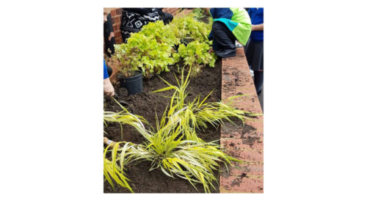](https://metisconsultants.co.nz/case-studies/suds-in-sutton-schools/)

[WSUD in Sutton Schools](https://metisconsultants.co.nz/case-studies/suds-in-sutton-schools/)

Having supported Sutton in securing Environment Agency Grant in Aid funding, Metis were commissioned to develop WSUD designs on seven school sites and one council site, to mitigate flooding to over 100 properties and deliver environmental benefits.

[Read](https://metisconsultants.co.nz/case-studies/suds-in-sutton-schools/)



Our civil and environmental engineers work with you to understand your unique needs and offer unparalleled support throughout every project.

Contact

2 Morgan Street, Newmarket, Auckland 1023

[022 071 4653](tel:0220714653)

[info@metisconsultants.co.nz](mailto:info@metisconsultants.co.nz)

[Linkedin](https://www.linkedin.com/company/metis-consultants-nz/)

Sitemap

* [About Us](https://metisconsultants.co.nz/about-us/)
* [Join Us](https://metisconsultants.co.nz/careers/)
* [The Team](https://metisconsultants.co.nz/about-us#the-team)
* [News](https://metisconsultants.co.nz/news/)
* [Three Waters](https://metisconsultants.co.nz/water/)
* [Case Studies](https://metisconsultants.co.nz/case-studies/)
* [Asset & Carbon Management](https://metisconsultants.co.nz/asset-carbon-mgmt/)
* [Privacy Policy](https://metisconsultants.co.nz/privacy-policy/)
* [Land Development](https://metisconsultants.co.nz/land-development/)
* [Contact Us](https://metisconsultants.co.nz/contact-us/)

© Metis Consultants Ltd. 2024 | Red 13 Web Design

This website uses cookies to improve your experience. We'll assume you're ok with this, but you can opt-out if you wish. Cookie settingsACCEPT