20250717 Metis website stormwater Whangamata
https://metisconsultants.co.nz/case-studies/whangamata-stormwater-master-plan/
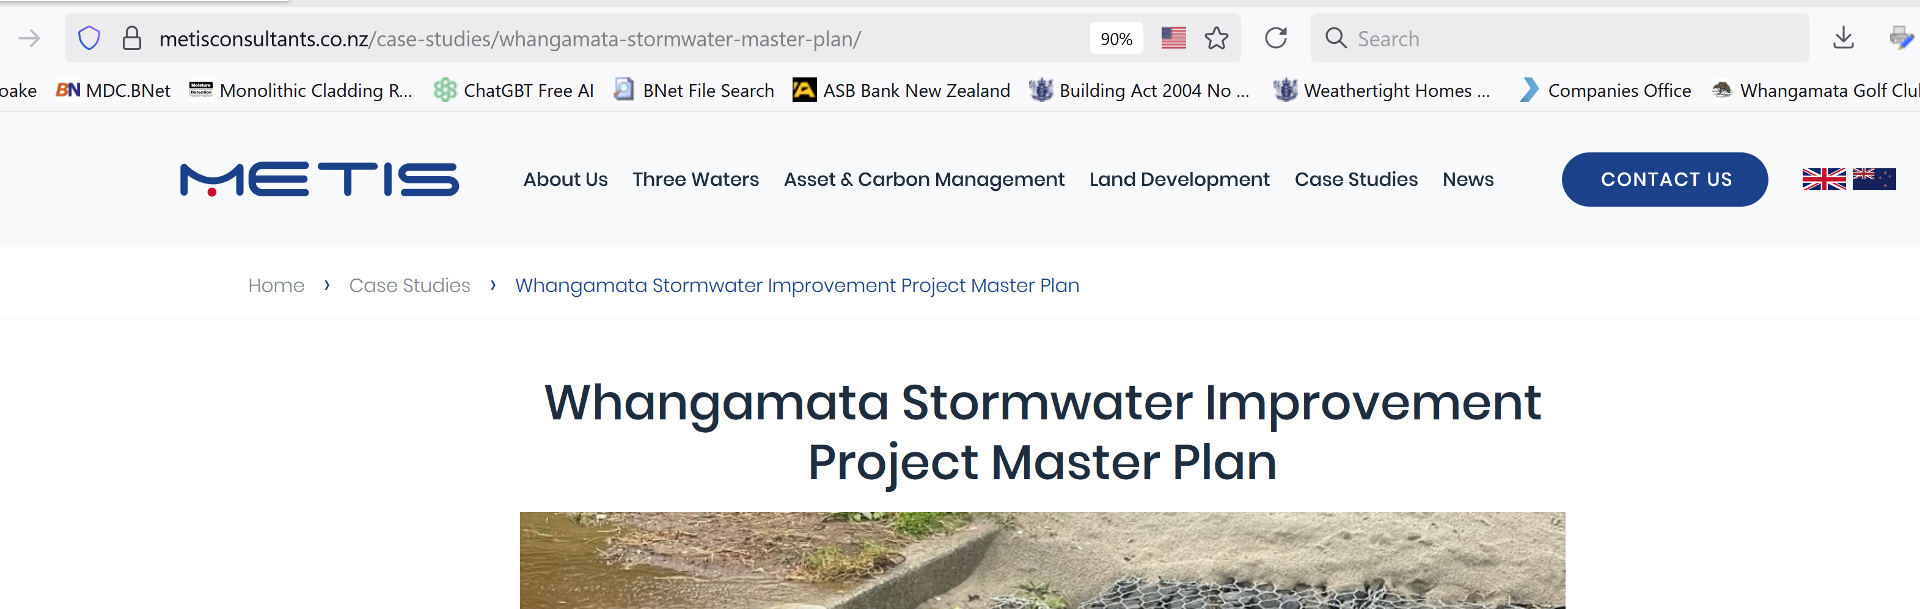

Whangamata Stormwater Improvement Project Master Plan
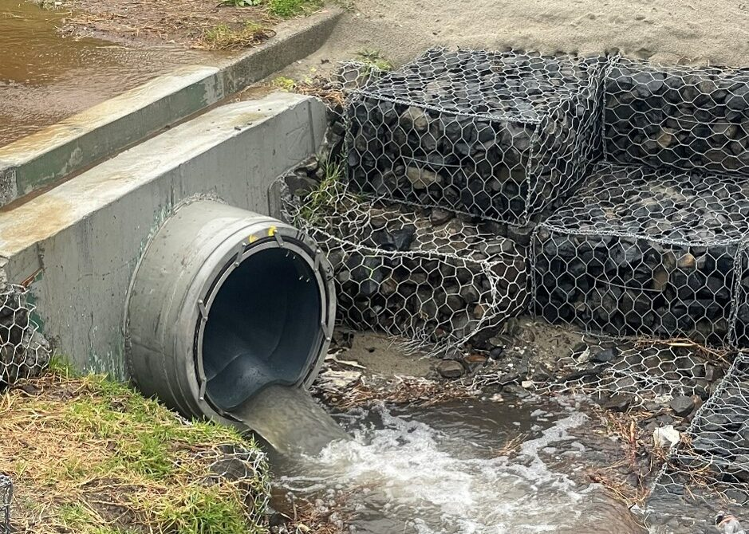

Project overview
Metis worked with Thames-Coromandel District Council to generate a multi-year programme of stormwater works in Whangamata.

Our approach
- Identify homes and critical infrastructure at greatest risk of stormwater flooding
- Generate mitigation options for each area at risk
- Engage with residents to prioritise mitigation options
- Generate an annualised implementation programme based on resident feedback and available funding

Outcomes
- Improved stormwater management: Proposed works will transport stormwater away from homes and businesses, reducing risk of flood damage
- ‘Bang for buck’: Targeted programme of stormwater works that benefits the most people relative to capital cost
- Climate change resilience: Pipe networks designed to better accommodate climate-change driven increases in rainfall as well as sea level rise

PROJECT CONTACT
Michael Arthur
Project Director
E: michael@metisconsultants.co.nz
T: 022 071 4653

